Chapter 2

Theory of Clocked Storage Elements

The function of a clocked storage element: is to capture the information at a particular moment in time and preserve it as long as it is needed by the digital system. Having said so, it is not possible to define a storage element without defining its relationship to a clocking mechanism in a digital system, which is used to determine discrete time events. This definition is general and should include various ways of implementing a digital system. More particularly the element that determines time in a synchronous system is the clock.

2.1 Latch based clocked storage elements

A simplest storage element consists of an inverter followed by another inverter providing a positive feedback as shown in Fig. 2.1.a. The information bit at the input is thus locked due to the positive feedback loop and it can be only changed “by force”, (i.e. by forcing the output of the feedback inverter to take another logic value). This configuration is very frequently used and is also known as the“keeper”, – a circuit that keeps (preserves) the information on a particular node.

If we were to avoid the power dissipation associated with overpowering (forcing), the keeper to change its value, we must introduce nodes that will help us in changing the logic value stored in the feedback loop. For that purpose we are free to use logic NAND or NOR gates, as shown in Fig. 2.1. Particularly interesting is a simple modification of the diagram, which highlights the Sum-of-Products nature of this logic topology. We start with a simple cross-coupled inverter pair which is unrolled to better illustrate the positive feedback that exists (Fig.2.1.a). In the second step we replace the inverters with NAND gates which enables us to control the variable inside the loop and to selectively set it to “1” or “0” using the input which controls the gate S and R in this case (as shown in Fig. 2.1.b). Finally we apply De Morgan rules which allows us to transform this structure into AND-OR topology. It is well known in digital design that this topology represents Sum-of-Products (SOP), thus a general expression for any Boolean function. The existence of this topology leads to the “Earl’s Latch” (Earl 1965).

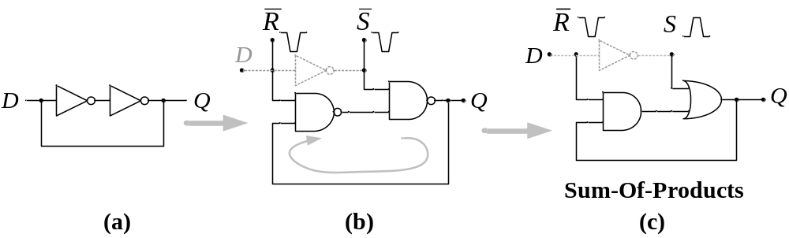
Fig. 2.1: Latch structure: (a) keeper (b) S-R latch (c) SOP latch

It is easy to derive a Boolean equation representing a behavior of the presented S-R latch. The next output Q_{n+1} is a function of Q_{n}, S and R signals. Later in this book we will exploit those simple dependencies in order to design improved clocked storage elements. Presented S-R latch can change the output Q at any point in time. In order to make it compatible with the synchronous design we will restrict the time when Q can be affected by introducing the clock signal which gates S and R inputs. If the data input D is connected to S, and the property of S-R latch, which makes S and R mutually exclusive is applied, the resulting D latch is shown in Fig. 2.2 (a). The associated timing diagram of a D-Latch is shown in Fig. 2.2 (b). The latch is transparent during the period of time in which clock is active, – i.e. assuming logic 1 value.

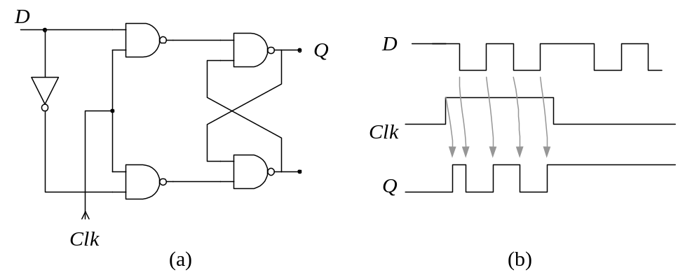
Fig. 2.2: (a) Clocked D-Latch (b) timing diagram of clocked D-Latch

A latch can be built in a Sum-of-Product topology (Fig. 2.1 (c) ). This tells us that it is possible to incorporate logic into the latch, given that the Sum-of-Products is one of the basic realizations of the logic function. This leads to construction of the “Earl’s Latch” which was introduced during the course of development of a well-known IBM S360/91 machine (Earl 1965, Flynn 1966, Amdahl 1964, Anderson et al. 1967). Basic Earl’s Latch configuration is shown in Fig. 2.3 (a),(Earl 1965), while a latch implementing the Carry function is shown in Fig. 2.3 (b) (Halin and Flynn 1972).

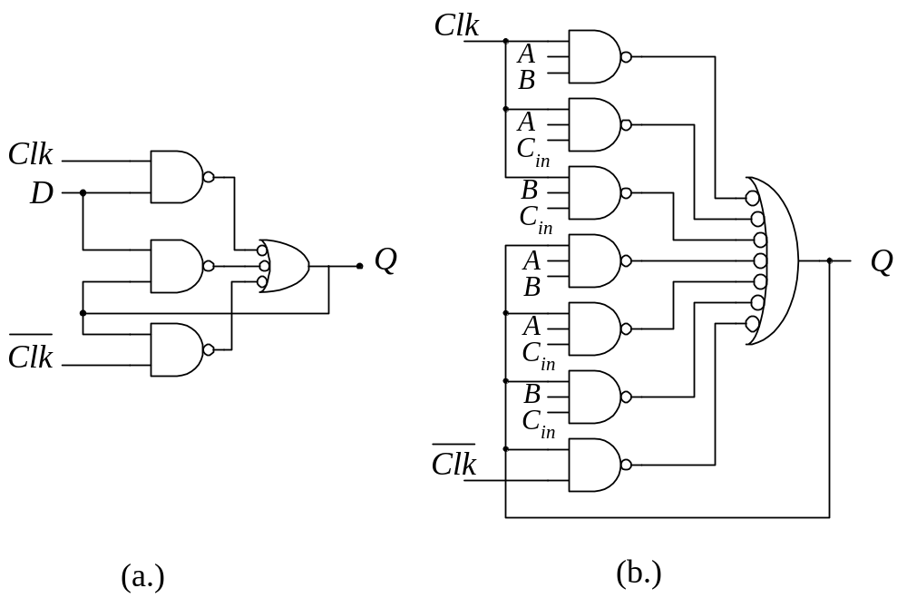
Fig. 2.3: (a) Basic “Earl’s Latch” (b) Implementing the “Carry” function

In order to avoid the transparency feature introduced by the latch, an arrangement is made in which two latches are clocked back to back with two non-overlapping phases of the clock. In such arrangement the first latch serves as a “Master”, by receiving the values from the Data input D and passing them to the “Slave” latch, which simply follows the “Master”. This is known as a Master-Slave (M-S) Latch (or L1 – L2 latch, in IBM) as shown in Fig. 2.4 This is not a “Flip-Flop” as we will explain this difference later in this book. A most common VLSI implementation of Master-Slave Latch is Transmission-Gate Master-Slave Latch (MSL), used in PowerPC (Gerosa et al. 1994), as shown in Fig. 2.4.d.

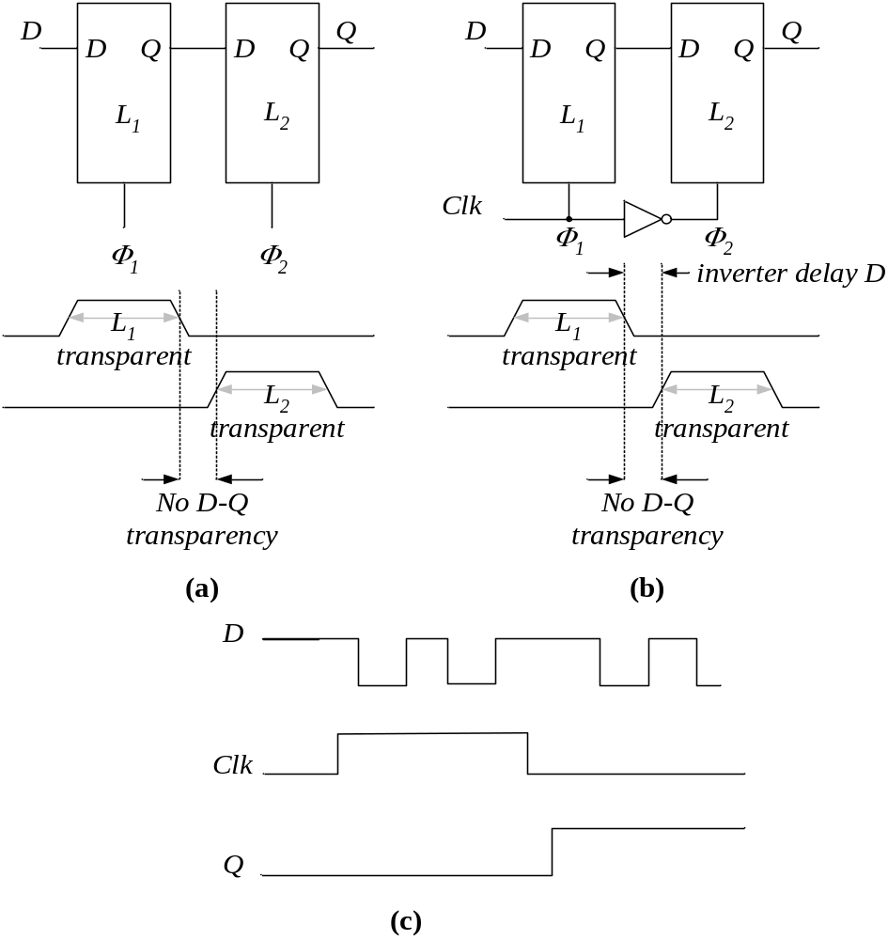
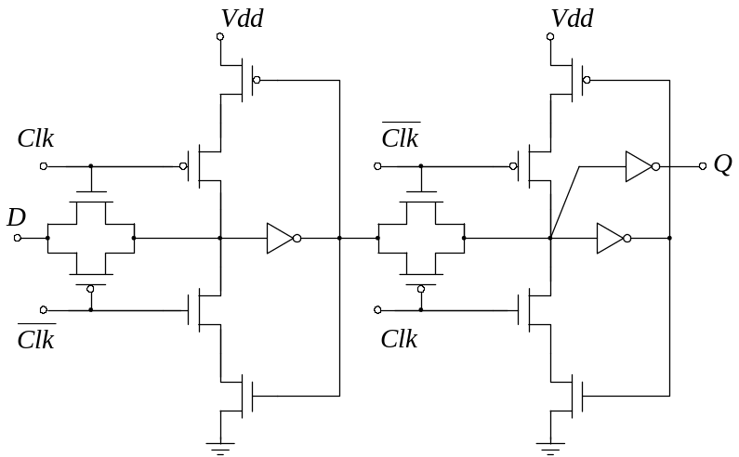

(d)
Fig. 2.4: Master-Slave Latch with: (a) non-overlapping clocks (b) single external clock (c) timing diagram (d) as used in PowerPC 603 (Gerosa, JSSC 12/94)

In a Master-Slave arrangement the “Slave” latch can also have two or more masters acting as an internal multiplexer with storage capabilities. The first “Master” is used for the capturing of data input while the second Master be used for other purposes and can be clocked with a separate clock. One such arrangement, which utilizes two Masters, is a well-known IBM Level-Sensitive-Scan-Design (LSSD 1985) shown in Fig.2.5.

In systems designed with LSSD compliance (Fig.2.5), the system is clocked with clocks C and B during the normal operation and the storage elements are acting as standard M-S Latches. However, all storage elements in the system are interconnected in a long shift register using the alternate Master. The input and the output of such shift-register are brought out to the external pins. In the test mode, the system is clocked with A and B, acting as a long shift register so that the state of the machine can be scanned out of the system and/or a new state scanned in. This greatly enhances the controllability and observability of the internal nodes of the system. LSSD is a mandated standard practice of all IBM designs and it has migrated into the industry under the name of “Boundary Scan” (IEEE Standard 1149).

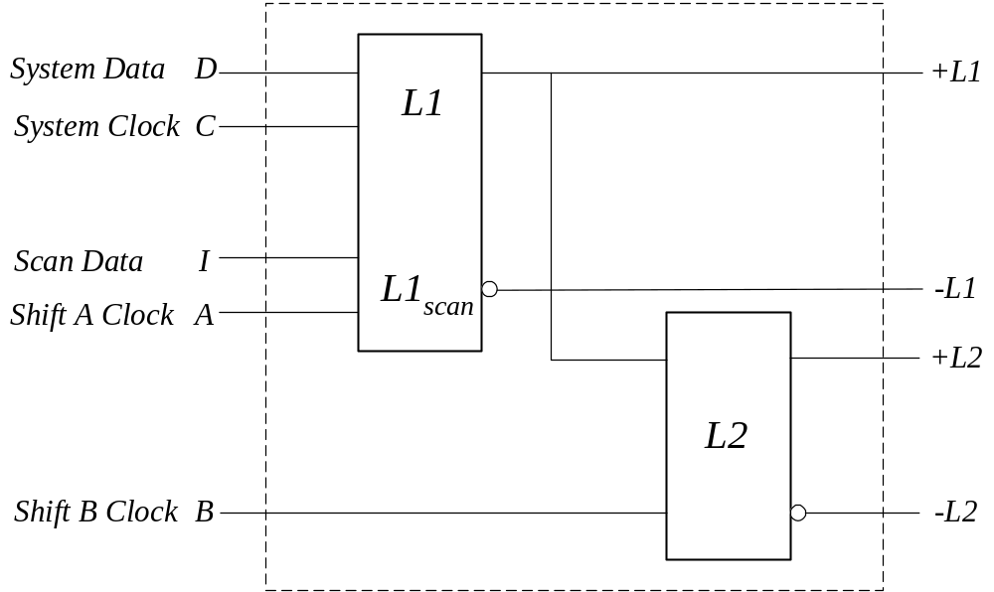

Fig. 2.5: IBM LSSD compatible storage element

2.1.1 True-Single-Phase-Clock (TSPC) latch

TSPC Latch (Fig. 2.6), developed by Yuan and Svensson (Yuan and Svensson 1989) is a fast and simple structure that uses a single-phase clock. This latch was constructed by merging two parts consisting of CMOS Domino and CMOS NORA logic (Goncalves and De Man 1983). During the active clock (Clk=1), CMOS Domino evaluates the input in a monotonic fashion (only a transition from logic 0 to 1 is possible), while NORA logic is pre-charging. Alternatively, during inactive clock (Clk=0) Domino is being pre-charged (thus is non-transparent) while NORA is evaluating its input. The combination of NORA and Domino logic stages results in a non-transparent Master-Slave Latch that requires only a single clock. Hence the name given to it was True-Single Phase Clock latch (TSPC). The clock system based on TSPC Latch is described in (Afghahi and Svensson 1990).

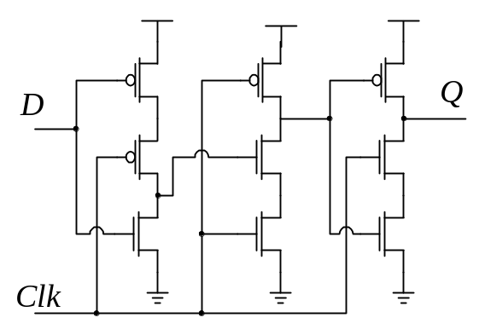

Fig. 2.6: True Single Phase Clock (TSPC) Latch introduced by Yuan and Svensson (Yuan and Svensson 1989)

The operation of TSPC Latch is illustrated in Fig. 2.7. When Clk=0, the first inversion stage L₁, is transparent and the second half L₂ of TSPC is pre-charged. Thus, at the end of the half-cycle during which Clk=0, the input D is present at the input of the Domino block as its complement. When the clock switches to logic 1 (Clk=1), Domino logic evaluates and the output either stays at logic 0 or makes transition from 0 to 1 depending on the sampled input value . This transition cannot be reversed until the next clock cycle. In effect the first inverter connected to the input acts as a Master Latch, while the second (Domino) stage acts as a Slave Latch. The transfer from the Master Latch to the Slave Latch occurs while the clock changes its value from logic 0 to logic 1. Thus, TSPC behaves as a “leading edge” triggered Flip-Flop. It is also frequently called a Flip-Flop, though by the nature of TSPC operation this classification is incorrect.

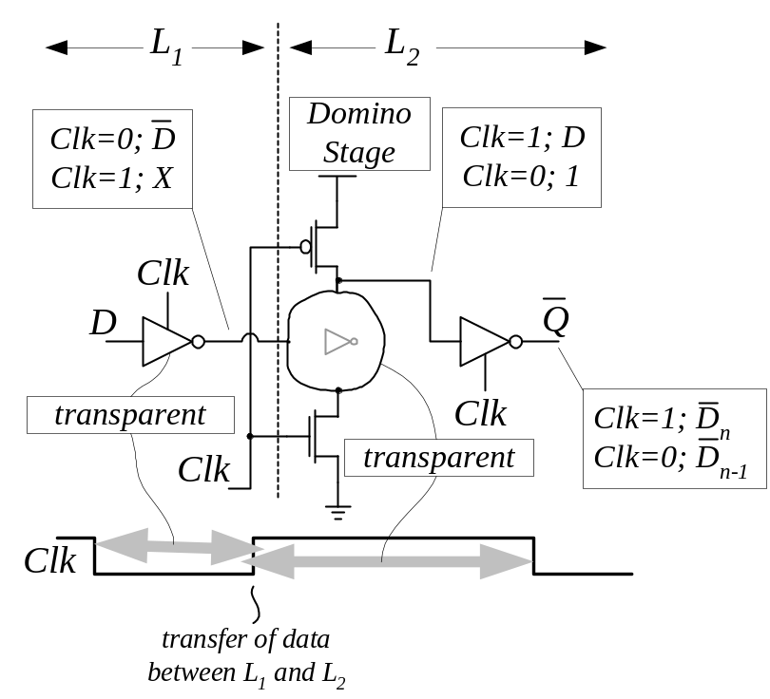
Fig. 2.7: TSPC Latch operation

Due to its simplicity and speed TSPC was a very popular way of implementing clocked storage element. However, TSPC exhibited sensitivity to glitches created by the clock edges. This glitch is exhibited on the output holding a logic value of “1”, while the input is receiving D=0.

2.1.2 Pulse Register Single Latch

Recognizing the overhead imposed by Master-Slave latch design and the potential “signal race” hazards introduced by a single-latch design, an idea of a single latch design clocked by locally generated short pulses evolved. The idea is to make a clock pulse very short and thus reduce the time window during which the Latch is transparent. However, there exist a hazard of a “short path” that may be captured during the same clock. Given that the clock pulse is short, this hazard is reduced and it is also possible to “pad” the logic (add inverters) in those paths so that they would not represent a problem. Such a short clock pulse cannot be distributed globally because the clock distribution network would absorb it. There is an additional danger because due to the process variations, the duration of that clock pulse will vary locally on the chip, and from chip to chip. In order to mitigate these problems, the pulse clock is generated locally and it usually drives a register consisting of several such single-latches located physically very close to each other. This method would loose its advantages of simplicity and low power if every single latch would require separate clock generator as seen from Fig. 2.8 (a) and (b) (Kozu 1996).

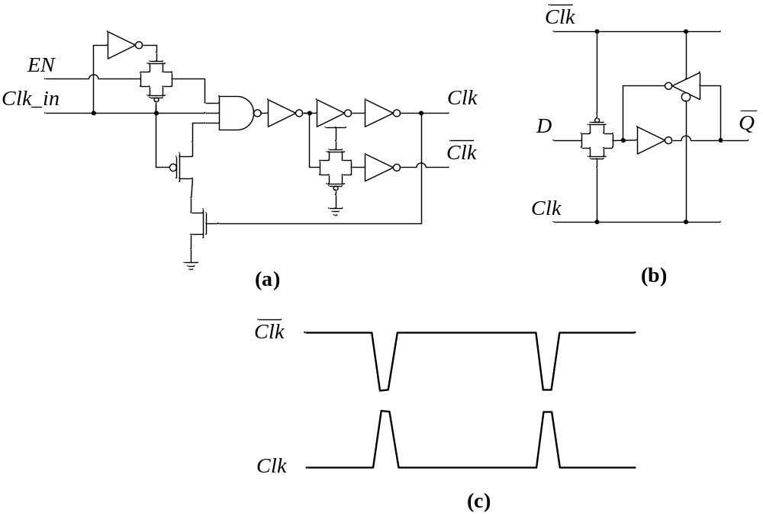
Fig. 2.8: Pulse Latch: (a) local clock generator, (b) single latch (Kozu 1996) (c) clock signals

The clock produced by local clock generator must be wide enough to enable the Latch to capture its data. At the same time it must be sufficiently short to minimize the possibility of “critical race”. Those conflicting requirements make use of such single-latch design hazardous by reducing the robustness and reliability of such design. Nevertheless, such design has been used due to the critical need to reduce cycle overhead imposed by the clocked storage elements. Intel’s version of Pulsed Latch is shown in Fig. 2.9. Another benefit of this design is low power consumption due to the common clock signal generator and a simple structure of the latch.

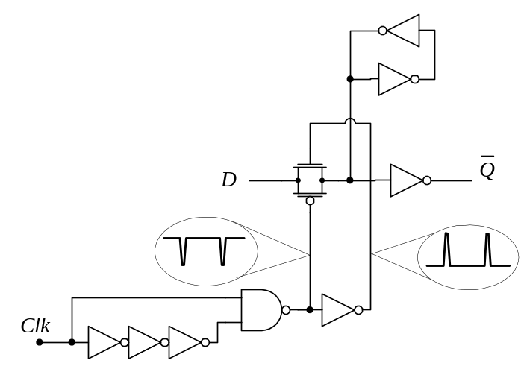

Fig. 2.9: Pulse Latch: Intel’s Explicit Pulsed Latch (Tschanz 2001)

Pulse generator used in Intel’s Pulsed Latch uses the principle of re-convergent fan-out with non-equal parity of inversion in order to obtain desired short clock pulse.

2.2 Flip-Flop

The main feature of the Flip-Flop is that the process of capturing data is related to the transition of the clock (from 0–to-1 or from 1-to-0), thus the Flip-Flop is not transparent. Therefore Flip-Flop based systems are easier to model and the timing tools find Flip-Flop based systems simpler and less problematic to analyze. The precise point in time when data is captured is determined by the clock event designated as either leading or trailing edge of the clock. In the other words, the transition of the clock from logic 0-to-1 causes data to be captured (it is the 1-to-0 transition in the trailing edge triggered Flip-Flop). In general, Flip-Flop is not transparent since it is assumed that the clock transition is almost instantaneous. As we will see later, even the Flip-Flop can have a very small period of transparency associated with the narrow time window during which the clock changes, as it will be discussed later. In general we treat Flip-Flop as a non-transparent clocked storage element. Given that the triggering mechanism of a Flip-Flop is the transition of the clock signal, there are several ways of deriving the Flip-Flop structure. For better understanding of its functionality it helps to look at an early version of the Flip-Flop, shown in Fig.2.10, and used in early computers and digital systems (see Siewiorek et al. 1982). The pulse, which causes the change, is derived from the triggering signal (also referred to as “trigger”) by using a simple differentiator consisting of a capacitor C and resistor R. One can also understand a danger introduced by the Flip-Flop. If the triggering signal transition is slow, a pulse derived in this way may not be capable of triggering the Flip-Flop. On the other hand, even a small glitch on the trigger line may cause a false triggering.

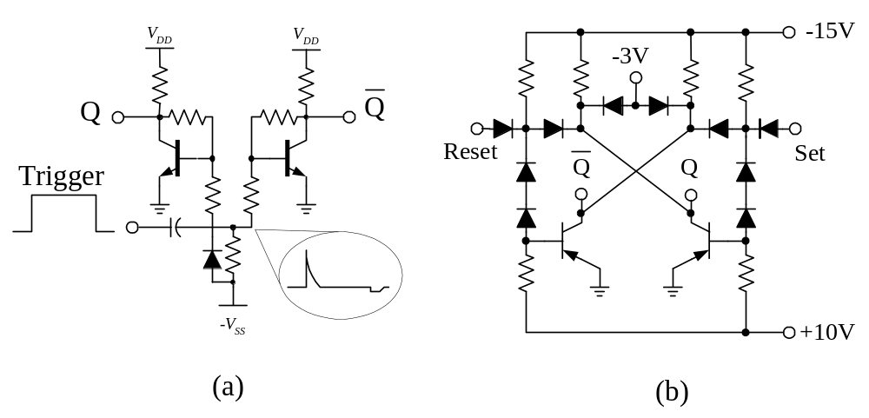
Fig. 2.10: (a) Early version of a Flip-Flop (b) PDP-8 direct Set-Reset sequential element

To elaborate in further understanding of the Flip-Flop it is helpful to start drawing the distinction between the Flip-Flop and the Latch based CSE.

The Flip-Flop and the Latch operate on different principles. While the Latch is “level-sensitive” meaning it is reacting on the level (logical value) of the clock signal, Flip-Flop is “edge sensitive”, meaning that the mechanism of capturing the data value on its input is related to the changes of the clock signal. Level sensitivity implies that the latch is capturing the data during the entire period of time when the clock is active (logic one), thus the latch is transparent. The two are designed to a different set of requirements and thus consist of inherently different circuit topologies.

A general structure of the Flip-Flop is shown in Fig. 2.11 (a). The difference between a Flip-Flop structure and the M-S Latch, shown in Fig. 2.11 (b) is in following:

Flip-Flop consists of two stages, a Pulse Generator - PG and a pulse Capturing Latch – CL. The pulse generator PG generates a negative pulse on either 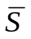 or 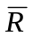lines, which are normally held at logic “1”. The resulting pulse is a function of Data and Clock signals and it should be of sufficient duration to be captured in the pulse Capturing Latch CL. The duration of the pulse produced by the PG stage, can be as long as half of the clock period, or it can be as short as one inverter delay.
On the other hand, the M-S Latch consists of two identical clocked latches and its non-transparency is achieved by phasing the clocks C₁ and C₂, which are clocking the Master, Latch L₁ and the Slave Latch L₂.

No Clock
Flip-Flop
M-S Latch
Pulse Capturing Latch
Pulse
Generator
Clock
Q
Q
Data
Data
Slave
Latch
Master
(L
1
)
Latch
Clock:
Φ
1
Q
Q
Data
Data
Slave
(L
2
)
Latch
Clock:
Φ
2
Q
1
Q
2
Q
1
Q
2
S
R
(a) (b)
Fig. 2.11: (a) General Flip-Flop structure (b) General Master-Slave Latch structure

In spite of different topologies for Flip-Flop and Master-Slave Latch, it may seem, that because their outward appearance is the same, there is no difference between the two. Further, reader may believe that the distinction imposed between Flip-Flop and Master-Slave Latch is artificial and only of the academic interest. In Fig. 2.12.a. the “black-box” view of the Flip-Flop and Master-Slave Latch is shown. It appears that Master-Slave Latch behaves identically as the “trailing-edge” triggered Flip-Flop, thus, no difference between the two is apparent. However, if the rise (or fall) time of the triggering edge of the clock increases, there will be a time at which Flip-Flop will fail. This is illustrated in Fig. 2.12.b, where a comparison of “leading-edge” triggered Flip-Flop and Master-Slave Latch is shown. Master-Slave Latch will continue to operate correctly because the capturing mechanism of both, Master and Slave latches, is related to the clock “level”, not to the rate of change. There are several reasons to why Flip-Flop may fail:

- Degradation of the rate of the change of the clock signal (clock edge degradation) may diminish the level and duration of the internally produced pulse that sets the CL.
- Difference in threshold levels of the gates used (due to the process variation) may cause the timing difference to behave differently than expected resulting in no pulse being produced.
- Any spurious glitch on the clock signal may cause false triggering of the Flip-Flop.

The experiment, shown in Fig. 2.12, demonstrates the difference between the Flip-Flop and Master-Slave Latch. This sensitivity of the Flip-Flop on the rate of the triggering edge makes Flip-Flop potentially hazardous and a reliability problem in the systems where we can not guarantee that the clock signal will suffer no degradations. This is particularly important regarding clock edge degradation and noise on the clock signal lines.

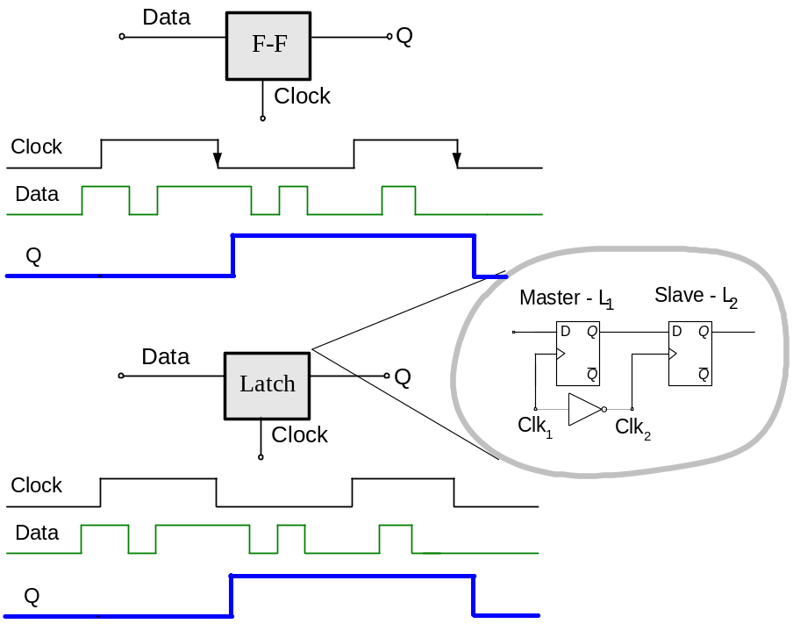

(a)

Data
Q
FF
Clock
F-F
Data
Q
L
Clock
Clock
Data
Latch
Q
L
Q
FF
Flip-Flop failed !

(b)
Fig. 2.12: (a) “Black-Box” view of the Flip-Flop and Master-Slave Latch (b) Experiment causing Flip-Flop to fail while Master-Slave Latch is still operational

Purely digital implementation of a Flip-Flop is far more intricate. For that analysis reader is referred to a commonly used SN7474 D-type Flip-Flop introduced by Texas Instruments shown in Fig.2.13 (Texas Instruments 1984). The analysis of SN7474 Flip-Flop, is particularly interesting. Even a brief analysis reveals that the operation of this particular Flip-Flop is based on the races in time inside the first stage of this Flip-Flop.

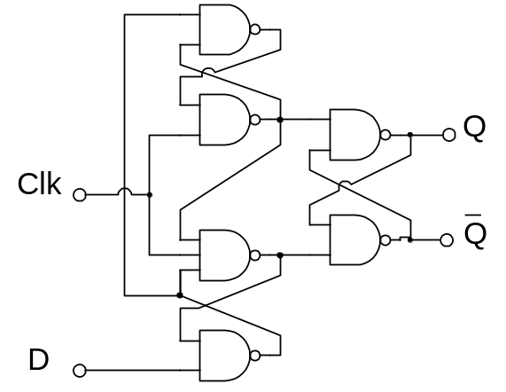

Fig. 2.13 Texas Instruments SN7474 Flip-Flop

The Pulse-Generator (PG) stage of the SN7474 is shown in Fig. 2.14 which may be helpful in the analysis of its operations and its failure modes. In order to behave as a Flip-Flop (to be sensitive to the change of the raising edge of the clock), an intricate race is introduced in the PG block that prevents any change on and lines after the clock has transitioned from logic “0” to “1” (Oklobdzija 1999). Fig.2.14 (a) is used to aid in analysis of the PG block of SN7474. Delay mismatch that can occur due to the process variations may result in malfunctioning of this Flip-Flop as shown in Fig. 2.14 (b). In the particular example shown, a race occurred between and signals which should be both stable at “1” after has made a brief transition to zero following the capture of D=1 on the raising edge of the clock. Signal should have stayed at “1” all the time. In this particular case, large difference in delay (due to the process variations) from one gate to another was the cause of this race.

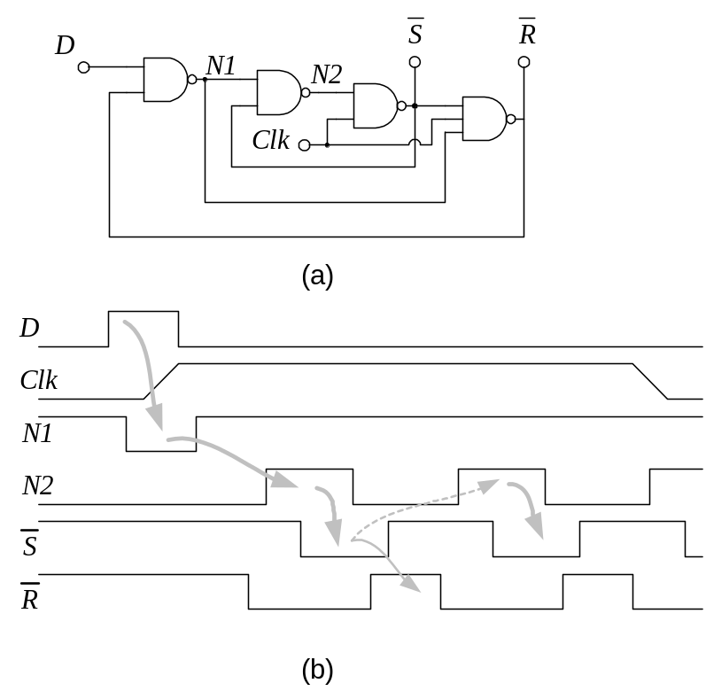
Fig. 2.14: (a) Pulse Generator block of SN7474 (b) malfunctioning due to a gate delay mismatch

The relationship of and signals with respect to Data (D) and Clock (Clk) signal can be expressed as:

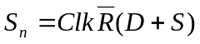 and 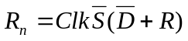 (2.1)

This expressions were derived strictly from the logic topology of SN7474 Flip-Flop, shown in Fig. 2.13. The expressions for the next value of the set signal S_{n} (as well as reset signal R_{n}) provide a quick and simple insight into the functioning of the PG block of this Flip-Flop. Simply stated in words, the equation for S_{n} tells us the following:

The next state of this Flip-Flop will be set to “one” only at the time the clock becomes “one” (raising edge of the clock), the data at the input is “one”, and the flip flop is in the “steady state” (both S and R are “zero”). The moment Flip-Flop is set (S=1, R=0) no further change in data input can affect the Flip-Flop state, data input will be “locked” to S_{n}=1 by (D+S)=1, regardless of D, and reset R_{n} would be disabled (by S=1).

This assures the “edge sensitivity”, i.e. after the transition of the clock and setting of the S_{n} or R_{n} signal to a desired state, the Flip-Flop is “locked”. No changes can occur until clock transition to “zero” (making both S=R=0), thus enabling the Flip-Flop to receive a new data.

Flip-Flop Derivation

Given the specifications set above that describe the Flip-Flop property, we can undertake the process of deriving the logic equations for the Flip-Flop. We know that the Flip-Flop consists of: (a) a Pulse Generator and (b) a pulse Capturing Latch CL (Fig. 2.11.a). Capturing Latch is a simple cross-coupled NAND (or NOR), Set-Reset Latch. We will see later in this book how this CL can be designed in a very efficient way (Stojanovic 2001). Pulse Generator stage is specified by their expected behavior. The value of the PG outputs, S and R, after the clock made its transition from 0-to-1 (triggering edge), is a function of the Clock, Data and the previous value of S an R. A description specifying S_{n} is given in the previous section. For clarity of presentation we will repeat it specifically for the required next value of S_{n} signal:

The next state of Flip-Flop should be set to “one” only at the time the clock becomes “one” (triggring edge of the clock), the data at the input is “one”, and the Flip-Flop is in the “steady state” (both S and R are “zero”). The moment Flip-Flop is set (S=1, R=0) no further change in data input can affect the Flip-Flop state.
Therefore S_{n} should become “one” when clock becomes “one” and Data is “one”. When this event occurs, Sn stays “one” and it can not revert back to “zero”, even if the Data signal changes back to “zero”.

It is quite simple to show these functional specifications simply on a Karnaugh map as shown in Fig. 2.15. Now we can derive logic equations from the functional specifications given in the Karnaugh map. These equations are shown and they are equivalent to the ones in the Eq. (2.1).

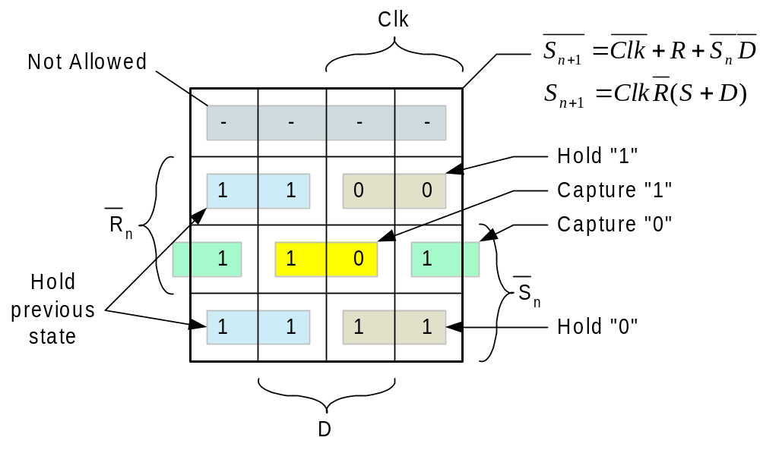
Fig. 2.15: Karnough map showing derivation of the Pulse Generating Stage of a Flip-Flop (only S_{n} signal is shown)

If we construct a Pulse Generator of the Flip-Flop from the equations obtained in such a way, it will result in the circuit topology shown in Fig. 2.16.c. Combining obtained PG stage with the improved second stage CL invented by Stojanovic (Stojanovic 2001) results in a superior Flip-Flop which was implemented by Nikolic (Nikolic et al 1999). This Flip-Flop is in the leading group of high performance Flip-Flops in terms of speed and energy delay product.

It is interesting to note that it took engineers several attempts to come to the right circuit topology of this Flip-Flop. The Flip-Flop used in the third generation of Digital Equipment Corp. 600MHz Alpha (Gronowski et al. 1998) processor uses a version of the Flip-Flop introduced by Madden and Bowhill, which was based on the static memory cell design (Madden and Bowhill 1990). This particular Flip-Flop is known as Sense Amplifier Flip-Flop (SAFF) (Matsui et al. 1994). Development of the Pulse Generator block of this Flip-Flop is illustrated in Fig.2.16.a.b.c.

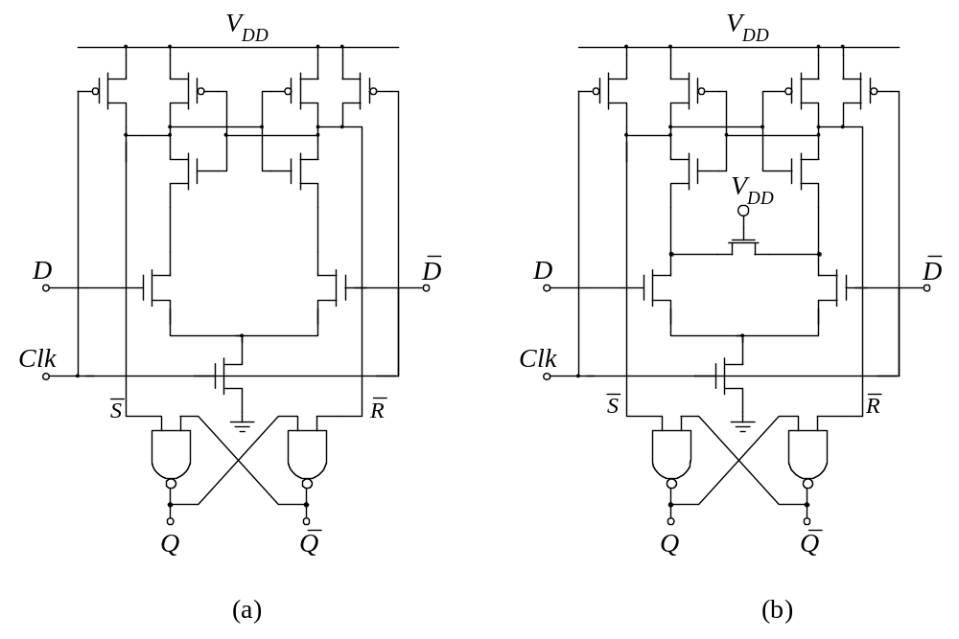

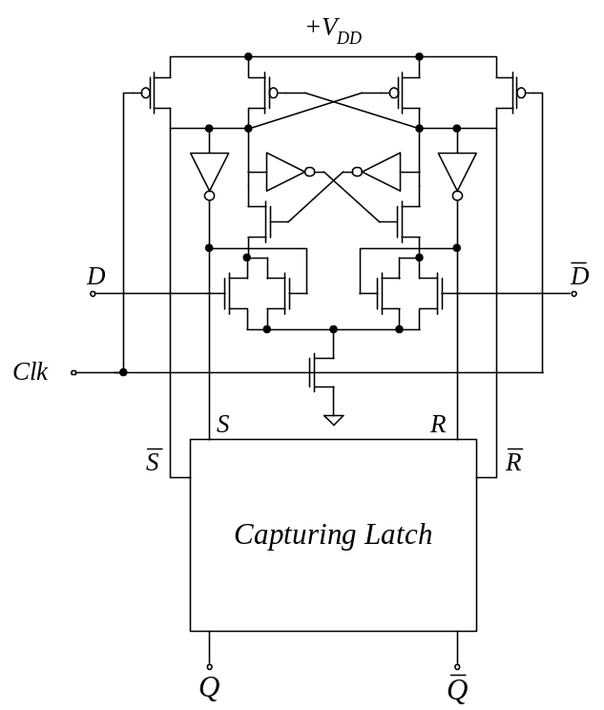
(c)
Fig. 2.16: (a) Pulse Generator stage of the Sense Amplifier Flip-Flop: Madden and Bowhill [US Patent No. 4,910,713] (b) Improvement for floating nodes, Dobberpuhl (Dobberpuhl 1997, Montanaro 1997) (c) Pulse Generator stage improvement by proper design (Nikolic and Oklobdzija 1999)

The behavior of SN7474 Flip-Flop and Alpha’s SAFF is identical. When setting the Flip-Flop, both of them hold the (or ) line at logic “zero” for the duration of the clock active, (“1”) and reset them to logic “1” once the clock returns to “0” (inactive state).

One of the objectives of this book is to clarify confusion that exists in understanding and properly classifying various types of clocked storage elements. In the next section we will show another way (used in practice) to create a Flip-Flop. In SN7474, disabling the D input is done after a short delay necessary to set S (or R) to the next value, thus achieving the “edge property”. That short delay is essential and cannot be avoided. It is reflected in the Setup and Hold time parameters of the Flip-Flop, which will be discussed later in this book.

2.2.1 Time Window based Flip-Flops

Derivation
Digital circuits are based on discrete events. Not only are the logic signals a set of discrete voltage levels, but the time is also based on either the clock (leading or trailing edge) or some other finite delay based on the signal propagation through one or more of the logic elements. Determining when to shut the Flip-Flop off is also based on a discrete time event with reference to the clock, or one or more inverter or gate delay units following the transition of the clock. This method is illustrated in Fig. 2.17, where one buffer delay serves as a time reference for shutting the Flip-Flop off. Thus, “clock edge” is created to last during a time interval (“window”) from Clk to Clk’, during which Flip-Flop may be transparent. When D =1 and Clk =1, S_{n+1} changes to 0 and immediately back to 1 as soon as Clk’ =1. At this point any change of D has no effect on S_{n+1}, because any further input transition is blocked. This describes Flip-Flop property: 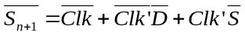 which means that S_{n+1} =0 only for a short period of time until Clk’=1 and afterwards the state is kept by the term 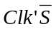, while data can have no effect because 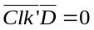. Thus, non-transparency is assured after the clock edge.

The common technique for generating the time reference is to create a short pulse using the property of re-convergent fan-outs with non-equal parities of inversion. Such arrangement using clock signal and three inverters with both paths re-converging as inputs of a NAND gate is shown in Fig. 2.9. The trailing edge of this pulse is used as a time reference for shutting off the Flip-Flop. Depending on the particular implementation a short transparency window may be introduced. This transparency window has been a source of confusion in classifying those Flip-Flops. One example is a Flip-Flop introduced under the name “Hybrid-Latch Flip-Flop” (HLFF). The existence of a short transparency window caused its inventor to treat it as a latch, but since its behavior was not of a latch, it was given a dual name: Hybrid-Latch Flip-Flop (Partovi et al, 1996). HLFF is shown in Fig. 2.18.

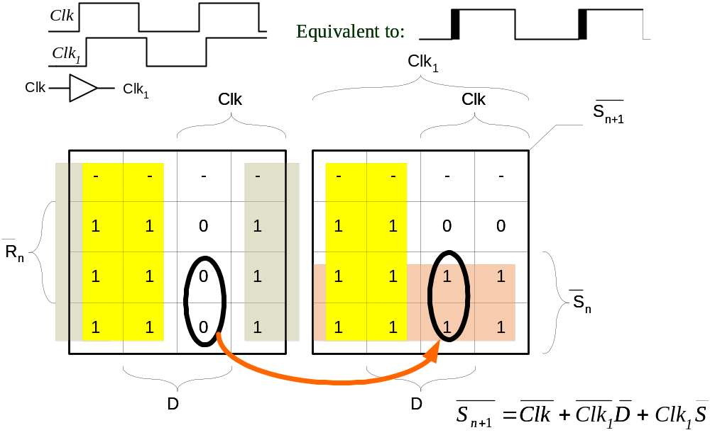
Fig. 2.17: Method of creating the time reference points for opening and shutting the Flip-Flop
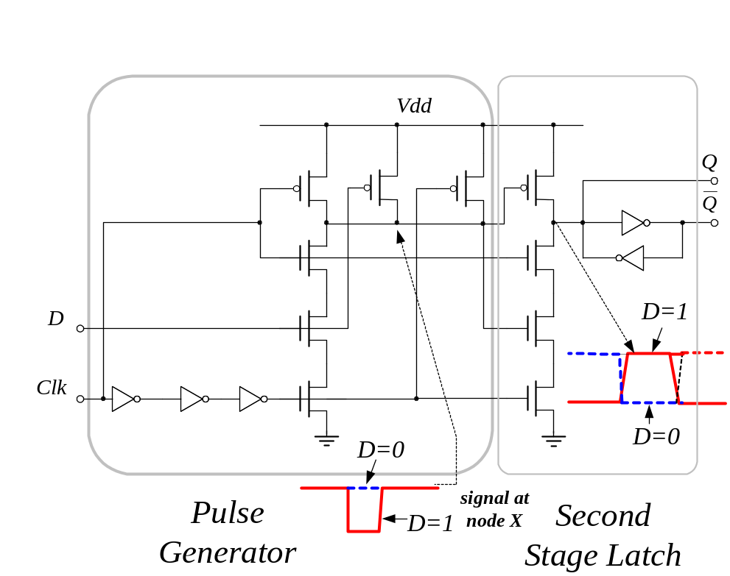
Fig. 2.18: Hybrid-Latch Flip-Flop (HLFF) introduced by Partovi (Partovi et al, 1996)

Detailed analysis shows that the number of transistors is reduced from the original specifications, which resulted in imperfections in this Flip-Flop behavior. Logic representation of this Flip-Flop shows two NAND gates connected in series (Fig. 2.19). The first NAND gate creates the pulse if D=1. Here, Data signal serves as a pulse enabler or pulse inhibitor, depending of the value of D.

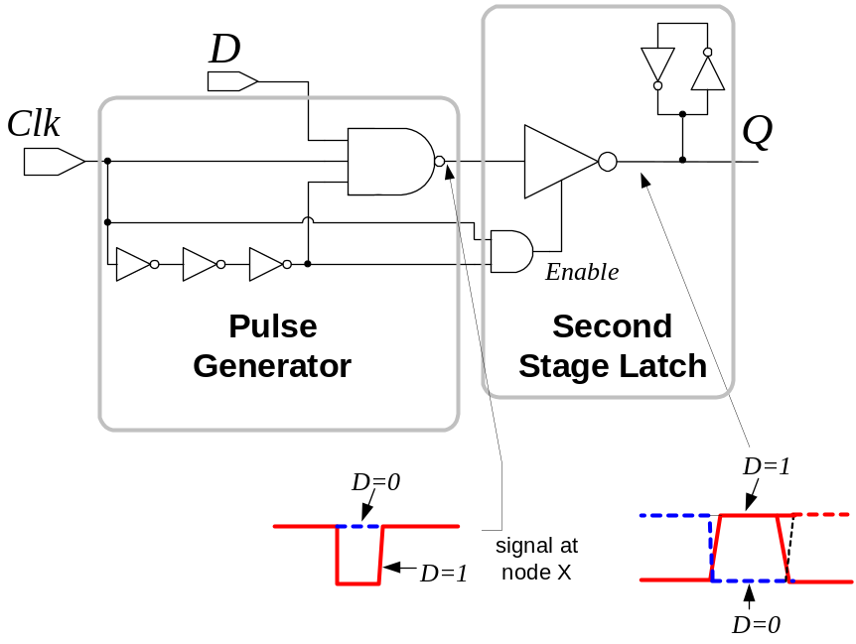
Fig. 2.19: Logic representation of Partovi’s Flip-Flop (HLFF)

The problem with this structure comes from incompleteness in the second stage, which serves as a clockless capturing latch CL. In order to avoid an excessive number of p-MOS transistors and obtain “Latch” functionality, the second NAND gate is not fully implemented and its output node is floating when the output node X (from the first NAND) is at logic “one” after the pulse has ended. In essence, this node (X) represents the signal from the pulse generator. The absence of the signal, due to the single ended implementation of this Flip-Flop hinders the ability to realize the Flip-Flop function completely. This is not the case of complete SAFF implementation (Nikolic and Oklobdzija 1999). The floating output node of HLFF is susceptible to glitches and even the slightest mismatch of clock signals between the first and second stage. When data input D=1, leading edge of the clock sets X=0 (pre-charged node) but after some propagation delay because it will take some time to make X=0 (set operation). For a short time after the leading edge of the clock, all three inputs of the second NAND gate will be “1”. This will cause a glitch on the output. This problem is an inherent problem of HLFF structure.

A systematic approach in deriving a single-ended Flip-Flop is shown in Fig. 2.20.

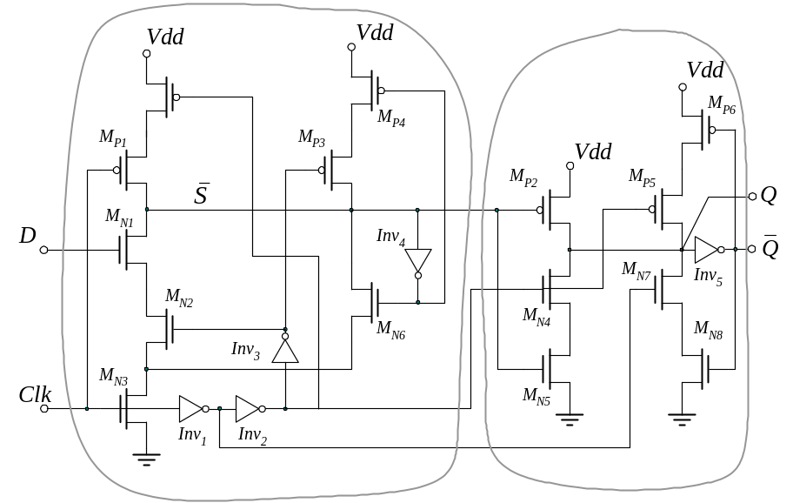

(a)
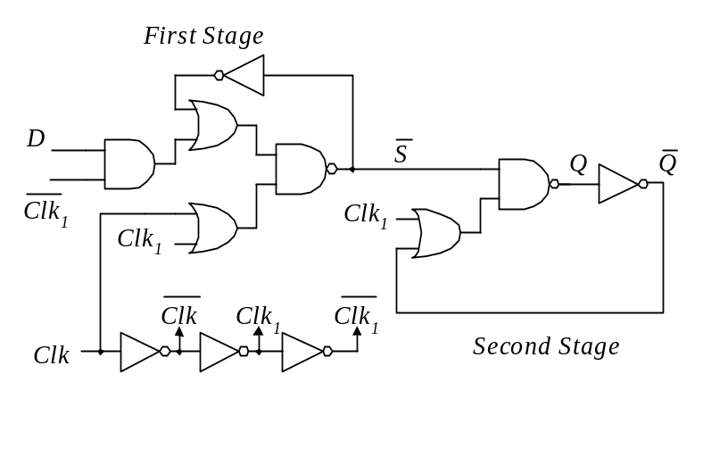
(b)

Fig. 2.20: Systematically derived single-ended Flip-Flop (Nedovic and Oklobdzija 2000a): (a) circuit diagram (b) logic representation

Flip-Flop, shown in Fig. 2.20. has three time reference points: (a) leading edge of the Clk signal, (b) trailing edge of the Clk signal after passing through three inverters: Inv₁₋₃, (c) leading edge of the Clk signal after passing through two inverters: Inv₁₋₂. The clock signal Clk, after two inversions is designated as Clk₂ while after three inversions as Clk₃. The logic representation of this Flip-Flop is shown in Fig.2.20.b. where the First and Second Stage are representing logic representation of the corresponding transistor blocks.

Derivation of this circuit models leading edge triggered Flip-Flop behavior using three time reference points. Equations describing the behavior of this Flip-Flop are given by Eq. (2.2)-(2.4):

The node X= is represented as:

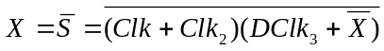 (2.2)

The nMOS transistor section is a full realization of Eq. (2.2). The pMOS section could be abbreviated for performance reasons into:

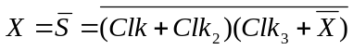 (2.3)

This provides small performance enhancement (by reducing capacitance on the node X) without significant degradation in reliability. The second stage (capturing latch) is implemented as:

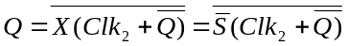 (2.4)

Clock signal Clk₂ is delaying capturing of the value on until the node stabilizes. This eliminates the hazard encountered in HLFF and SDFF Flip-Flops (Klass 1998 and 1999). In addition systematically derived Flip-Flop (Nedovic, Oklobdzija 2000a) exhibits better speed when compared to HLFF and SDFF.

References:

(Afghahi, and Svensson 1990) Afghahi, M. and Svensson, C. (1990) A unified single-phase clocking scheme for VLSI systems. IEEE Journal of Solid-State Circuits, vol.25, (no.1), Febryary, p.225-33.
(Amdahl 1964) Amdahl G. M, (1964) “The Structure of System /360, Part III: Processing Unit Design Considerations” IBM Systems Journal, Vol.3, No.2, p.144-164.
(Anderson et al. 1967) Anderson D.W, Sparacio F.J, and Tomasulo R.M, (1967) “The IBM System/360 Model 91: Machine Philosophy and Instruction Handling”, IBM Journal of Research and Development, Vol.11, No.1, p.8-24.
[4] Bailey, D.W.; Benschneider, B.J. (1998) “Clocking design and analysis for a 600-MHz Alpha microprocessor”, Solid-State Circuits, IEEE Journal of , Vol.33, No.11 , November 1998.
(Dobberpuhl 1997) Dobberpuhl, D.W. (1997) “Circuits and technology for Digital's StrongARM and ALPHA microprocessors”, Proceedings of the Seventeenth Conference on Advanced Research in VLSI, Ann Arbor, Michigan, September 15-16. p.2-11.
(Earl 1965) Earl J, (1965) “Latched Cary-Save Adder”, IBM Techical Disclosure Bulletin, Vol.7, No.10, March, p.909-910.
(Flynn and Amdahl 1965) Flynn M. J, Amdahl G.M, (1965) “Engineering Aspects of Large High Speed Computer Design”, Proceedings of the Symposium on Microelectonics and Large Systems, Spartan Press, Washington D.C. 1965.
(Flynn 1966) Flynn M.J, (1966) “Very High-Speed Computing System”, Proceedings of IEEE, Vol.54, No.12, December, p.1901-1909.
[9] Friedman E.G, (1995) “Clock Distribution Networks in VLSI Circuits and Systems”, IEEE Press, 1995.
(Gronowski et al. 1988) Gronowski, P.E, W. J. Bowhill, W.J, Preston, R.P, Gowan, M.K, and Allmon, R.L, (1998) "High-performance microprocessor design," IEEE Journal of Solid-State Circuits, vol. 33, pp. 676 - 686, May 1998.
(Halin and Flynn 1972) Halin TG and Flynn M.J, (1972) “Pipelining of Arithmetic Functions”, IEEE Transactions on Computers, Vol C-21, No. 8, August, p.880-886.
(Klass et al. 1999) Klass F et al, (1999) “A New Family of Semidynamic and Dynamic Flip-Flops with Embedded Logic for High-Performance Processors”, IEEE Journal of Solid-State Circuits, vol. 34, no. 5, pp. 712-716, May 1999.
(Klass et al. 1998) Klass F, (1998) “Semi-Dynamic and Dynamic Flip-Flops with Embedded Logic,” Symposium on VLSI Circuits, Digest of Technical Papers, pp. 108-109, June 1998.
[14] Kogge P, (1981) “The Architecture of Pipelined Computers”, McGraw-Hill Book Company, 1981.
(Kozu et al. 1966) Kozu, S, et al. (1996) “A 100 MHz, 0.4 W RISC processor with 200 MHz multiply adder, using pulse-register technique”, Digest of Technical Papers, 1996 IEEE International Solid-State Circuits Conference, San Francisco, 8-10 February. p.140-141.
(LSSD 1985) LSSD Rules and Applications, Manual 3531, Release 59.0, IBM Corporation, March 29, 1985.
(Madden and Bowhill 1990) Madden, W.C, Bowhill, W.J, (1990) "High input impedance, strobed sense-amplifier," United States Patent 4,910,713, March 1990.
(Montanaro et al. 1997) Montanaro, J.; Witek, R.T.; Anne, K.; Black, A.J.; Cooper, E.M.; Dobberpuhl, D.W.; Donahue, P.M.; Eno, J.; Hoeppner, G.W.; Kruckemyer, D.; Lee, T.H.; Lin, P.C.M.; Madden, L.; Murray, D.; Pearce, M.H.; Santhanam, S.; Snyder, K.J.; Stephany, R.; Thierauf, S.C. (1997) A 16O-MHz, 32-b, 0.5-W CMOS RISC microprocessor. Digital Technical Journal, Vol.9, No.1, Digital Equipment Corp, p.49-62.
(Nedovic and Oklobdzija 2000a) Nedovic N, Oklobdzija V.G, (2000a) Dynamic flip-flop with improved power. Proceedings of the IEEE International Conference on Computer Design: VLSI in Computers and Processors. ICCD 2000, Austin, Texas, September 17-20. p.323-326.
[20] Nedovic, N, Oklobdzija, V.G. (2000b) “Hybrid latch flip-flop with improved power efficiency”, Proceedings of the 13th Symposium on Integrated Circuits and Systems Design, Manaus, Brazil, September 18-24. p.211-15.
(Nikolic and Oklobdzija 1999) Nikolic, B, Oklobdzija, V.G, (1999) “Design and optimization of sense-amplifier-based flip-flops”, Proceedings of the 25th European Solid-State Circuits Conference, ESSCIRC'99., Duisburg, Germany, 21-23 September 21-23. p.410-13.
(Oklobdzija 1999) Oklobdzija V.G, (1999) “High-Performance System Design: Circuits and Logic”, Book, IEEE Press, July.
(Partovi et al. 1996) Partovi, H. et al, (1996) “Flow-through latch and edge-triggered flip-flop hybrid elements”, 1996 IEEE International Solid-State Circuits Conference. Digest of Technical Papers, ISSCC, San Francisco, February 8-10.
(Texas Instruments 1984) Texas Instruments (1984) “The TTL Data Book for Design Engineers”, Dallas, Texas, Texas Instruments.
[25] Unger S.H, Tan CJ, (1986) “Clocking Schemes for High-Speed Digital Systems”, IEEE Transactions on Computers, Vol. C-35, No 10, October 1986.
[26] Wagner K, (1988) “Clock System Design”, IEEE Design & Test of Computers, October 1988.
(Gerosa 1994) G. Gerosa et al, “A 2.2W, 80MHz superscalar RISC microprocessor”, IEEE Journal of Solid State Circuits, vol. 29, pp. 1440-1452, Dec. 1994.
(Tschanz et al. 2001) Tschanz James, Siva Narendra, Zhanping Chen, Shekhar Borkar, Manoj Sachdev, Vivek De, “Cmparative Delay and Energy of Single Edge-Triggered & Dual Edge-Triggered Pulsed Flip-Flops for High-Performance Microprocessors, Proceedings of the 2001 International Symposium on Low Power Electronics and Design, Huntington Beach, California, August 6-7, 2001.
(Stojanovic 2001) V. Stojanovic, V. G. Oklobdzija, FLIP-FLOP, US Patent No. 6,232,810, May 15, 2001.
(Yuan and Svensson 1989) Yuan, J and Svensson, C, “High-Speed CMOS Circuit Technique”, Journal of Solid-State Circuits, Vol.24, No.1, February 1989.
(Goncalves and DeMan 1983) N.F. Goncalves, H.J. DeMan, “NORA: A Racefree Dynamic CMOS Technique for Pipelined Logic Structures”, IEEE Journal of Solid-State Circuits, Vol. SC-18, No 3, June 1983.
(Matsui et al. 1994) M. Matsui, H. Hara, Y. Uetani, L. Kim, T. Nagamatsu, Y. Watanabe, A. Chiba, K. Matsuda, and T. Sakurai, "A 200 MHz 13 mm²2-D DCT macrocell using sense-amplifying pipeline flip-flop scheme," IEEE Journal of Solid-State Circuits, vol. 29, pp. 1482 - 1490, December 1994.

