Accessing Your ECE Account Remotely on Windows using RealVNC
--Swapnil S. Jain

The first thing you have to do is to download a client program called PuTTY. Here is one way to do this:
- Google “download putty ucdavis” and go to the first link that shows up. Then click on “putty.exe” to download PuTTY.

The next thing you have to do is to download RealVNC virtual network software. Here is one way to do this:
- Google “realvnc download” and go the very first link that shows up. Then download free edition of RealVNC by clicking on the appropriate ‘Download and use’ icon.

Once you have downloaded both of these programs, run putty.exe. You should see the following window pop-up:
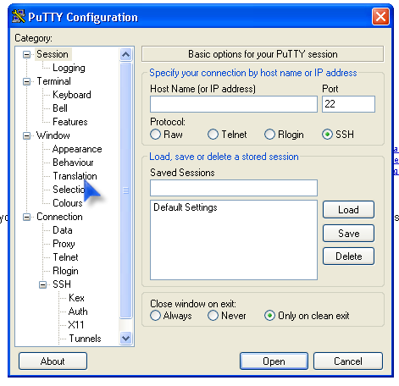

Now type “viper.ece.ucdavis.edu” under “Host Name (or IP address)” and click on “Open,” which will direct you to a black UNIX terminal window that will prompt you for you ECE username and password. After you have correctly entered your username and password, you will be directed to your ECE home directory.

Now type ‘vncserver’ on the command line. You should see something like this:
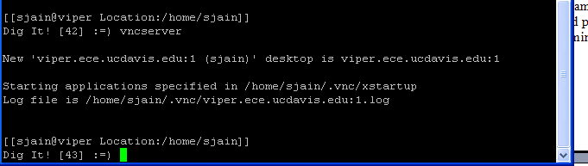

Note down the number that you see after the .edu and before the .log extension (here it is 1).

Now it is time to install RealVNC. Run your downloaded file and then walk through the instructions on the screen to install RealVNC on you computer. In the end, it will display the following window:
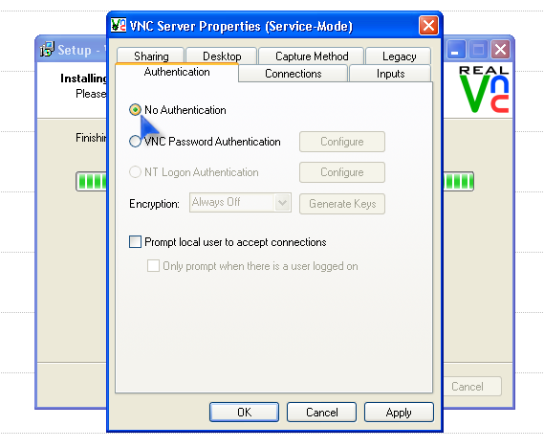

Select ‘No Authentication’ and click OK.

Once this is done, go to “Start->All Programs->RealVNC->VNC Viewer 4-> Run VNC Viewer” as shown below:

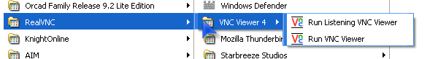

You should get the following window:
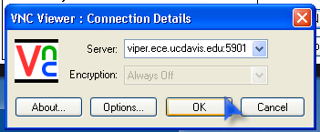

Type “viper.ece.ucdavis.edu:#” under “Server.” NOTE: the # here is the number that you noted down when you ran vncserver on putty (in this case it is1).

If everything goes right, a new widow will open which would contain your usual white terminal (but without your Linux Desktop). You are done at this point! You can run any program from this terminal virtually!

If you have a fast internet connection you may also want to enable the Desktop. You can do this by going to the “.vnc” folder in your ECE account and modifying the “.xstartup” file the following way:

Uncomment the following two lines as done below:


Now when you restart the vnc server and vnc viewers, you will be able to see your whole Desktop!

