 Interactive course on Arithmetic Operators
Demonstration Tuesday June 9, room INF 211, 10-12am
(Computer Arithmetic Course, host: Prof. V. G. Oklobdzija)
by Alain Guyot, TIMA, Grenoble
The interactive course explains the design of integrated combinatorial arithmetic operators. It is available on internet : http://tima-cmp.imag.fr/~guyot/Cours/Oparithm/english/Op_Ar2.htm An user's manual (70 pages) in PDF as well as course slides (only in French) are joined.
The interactive course offers 125 applets windows, most of them generate and simulates arithmetic operators. They are controlled through a "dash board" at the bottom, more or less similar to the example below.

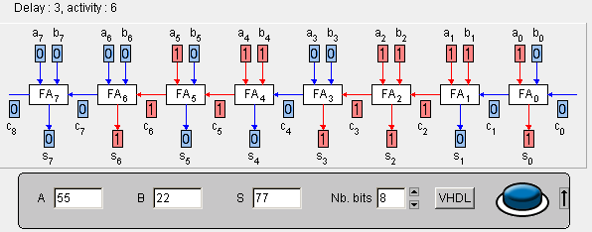

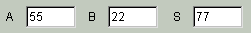The input and output bits can be set with the mouse. An automatic conversion to and from decimal is provided. After a modification, a decimal window is validated by hitting the "enter" key. Hitting "enter" twice starts the simulation. Arithmetic operators are "telescopic", meaning that it is easy to expand them to any number of bits. However to keep the figure readable on the screen the number of bits is limited, often to 16 or 32 bits (but less or not limited in the VHDL synthesis). A few operators lacking layout regularity are incompletely displayed.
Many applets generate a VHDL description of the operator. This file may be used for simulation or synthesis on FPGA or ASIC. A superficial knowledge of VHDL is sufficient to read the generated file. The VHDL describes as faithfully as possible the circuit on the screen.
Three criteria: complexity, delay and activity, ascertain an operator quality. Delay is measured by the applets in cell's delay (cell's delay model). Activity records the number of output changes (internal activity is not recorded).
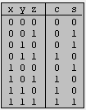Arithmetic operators are made of interconnected cells instances. Each operator makes use of a small number of cells models (typically from 1 to 3). A cell encapsulates a handful of logic gates. Each cell has three views: 1-the truth table (at right), 2-the VHDL model and 3-the layout. Clicking in a leaf cell on the screen shows its truth table. To hide the cell's name or the table, click outside the cell at the right.

Alain Guyot: is teaching computer architecture and VLSI design at ENSIMAG and Grenoble University since1971. He has been a visiting scholar and invited professor with the CSL group in Stanford University (Prof. M. Flynn), the Electronic Department in Telecom University, Paris (Prof. F. Jutand) and the LEG laboratory in EPFL, Lausanne, Switzerland (Prof. M. Declercq). In 1980 he participated in the starting of the CMP foundry service. Dr. Guyot is the author or co-author of more than 120 scientific contributions in Journals, Conference Proceedings, and Research Reports.

